1511 Wisconsin Avenue, NW
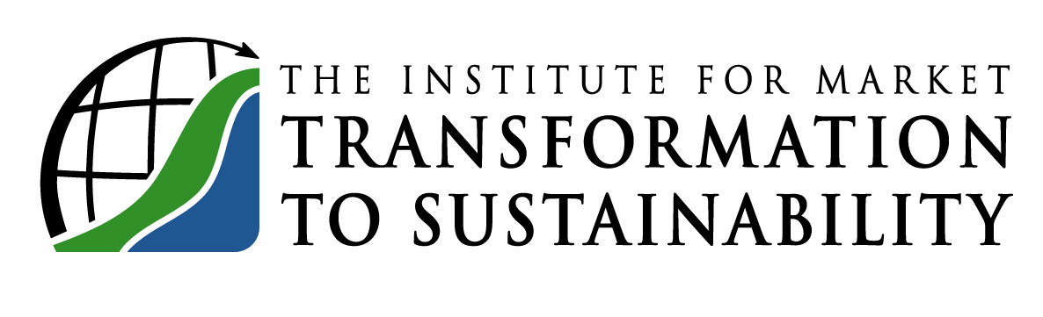
Washington, DC 20007

Telephone 202-338-3131
Fax 202-338-2800
Email MTS@sustainableproducts.com
Web http://MTS.sustainableproducts.com

_____________________________________________

Industry Trade Association Policy

Submitted to ANSI as Part of Due Diligence for ANSI Accreditation
March 31, 2005

1. Industry Trade associations are encouraged to fully participate as official MTS Members in the consensus standard setting MTS Committees. This participation must be only through one or more of their designated Members. In this manner, they may also participate in all Official MTS votes including Ballot votes. Such trade association Members are lawfully empowered to represent their trade association.

Where a trade association Member or more than one Member accepts this role, it may cast one vote for the trade association and one vote for the Company, yet it need only pay dues at the single Member rate.

Any trade association Member Company may individually join MTS as an official MTS Committee Member.

2. All MTS Consensus Committees are required to be balanced among users, producers and general interest Members, and Membership is by organization, and producers may not dominate the Committee.

3. Written comments from trade associations who elect not to participate in the manner defined in section 1 above, will be considered and responded to, and they may send in official Ballot votes, and if the vote is negative it will be resolved along with any other negative vote. However, such votes not from an official trade association Member pursuant to section 1 above, will not count in the Committee or Member and Interested Party Ballot Vote as to whether the Vote is approved or a successful Ballot vote. Any participation in Meetings, hearings, and appeals, and any inquiry must be in compliance with sections 1 & 2 above.

